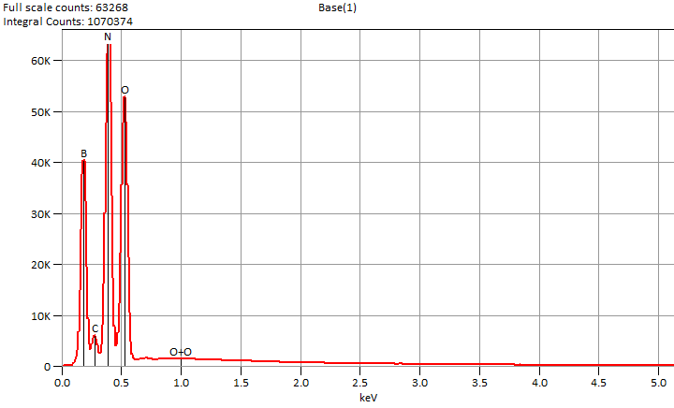

Live Time: 90.0 sec.

Wed Nov 27 13:55:59 2024

Filter Fit Chi Squared:325.673

Errors: +/- 1 Sigma

Correction Method: Proza (Phi-Rho-Z)

Acc.Voltage: 6.0 kV Take Off Angle: 36.3 deg.

Detector: UltraDry

WDS Results Unavailable for: Base(1)

|  |
| --- |
|  |

Quantitative Results for: Base(1)

|  |  |  |  |  |  |  |
| --- | --- | --- | --- | --- | --- | --- |
| ***Element***  ***Line*** | ***Int.***  ***Cps/nA*** | ***Int.***  ***Error*** | ***Weight %*** | ***Weight %***  ***Error*** | ***Atom %*** | ***Atom %***  ***Error*** |
| ***B K*** | 2301.2 | ± 22.67 | 16.6 | ± 0.2 | 21.6 | ± 0.2 |
| ***C K*** | 243.46 | ± 22.19 | 1.3 | ± 0.1 | 1.5 | ± 0.1 |
| ***N K*** | 3706.8 | ± 18.99 | 37.8 | ± 0.2 | 37.9 | ± 0.2 |
| ***O K*** | 3710.7 | ± 20.61 | 44.3 | ± 0.2 | 39.0 | ± 0.2 |
| ***Total*** |  |  | 100.0 |  | 100.0 |  |

ROI Results for: Base(1)

|  |  |  |
| --- | --- | --- |
| ***Operation*** | ***Gross Counts*** | ***Net Counts*** |

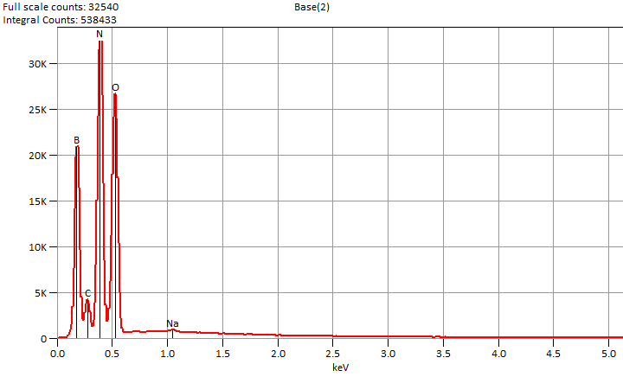

Live Time: 90.0 sec.

Wed Nov 27 14:05:47 2024

Filter Fit Chi Squared:131.717

Errors: +/- 1 Sigma

Correction Method: Proza (Phi-Rho-Z)

Acc.Voltage: 6.0 kV Take Off Angle: 35.7 deg.

Detector: UltraDry

WDS Results Unavailable for: Base(2)

|  |
| --- |
|  |

Quantitative Results for: Base(2)

|  |  |  |  |  |  |  |
| --- | --- | --- | --- | --- | --- | --- |
| ***Element***  ***Line*** | ***Int.***  ***Cps/nA*** | ***Int.***  ***Error*** | ***Weight %*** | ***Weight %***  ***Error*** | ***Atom %*** | ***Atom %***  ***Error*** |
| ***B K*** | 1190.7 | ± 12.94 | 16.7 | ± 0.2 | 21.7 | ± 0.2 |
| ***C K*** | 208.92 | ± 16.07 | 2.1 | ± 0.2 | 2.5 | ± 0.2 |
| ***N K*** | 1873.2 | ± 12.10 | 37.5 | ± 0.2 | 37.6 | ± 0.2 |
| ***O K*** | 1858.6 | ± 11.79 | 43.2 | ± 0.3 | 37.9 | ± 0.2 |
| ***Na K*** | 25.40 | ± 2.38 | 0.4 | ± 0.0 | 0.2 | ± 0.0 |
| ***Total*** |  |  | 100.0 |  | 100.0 |  |

ROI Results for: Base(2)

|  |  |  |
| --- | --- | --- |
| ***Operation*** | ***Gross Counts*** | ***Net Counts*** |

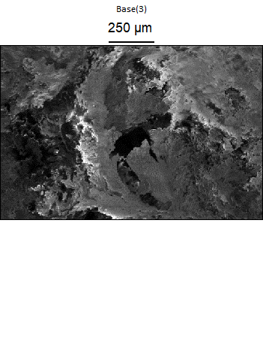

Data Type: Counts

Image Resolution: 512 by 340

Image Pixel Size: 2.77 µm

Map Resolution: 128 by 84

Map Pixel Size: 11.09 µm

Acc. Voltage: 6.0 kV

Magnification: 150

